Do you Know?

Americans throw away 50 billion food and drink cans, 27 billion glass bottles and jars, and 65 million plastic and metal jar and can covers.  More than 30% of our waste is packaging materials. Where does it all go? Some 85% of our garbage is sent to a dump, or landfill, where it can take from 100 to 400 years for things like cloth and aluminum to decompose. Glass has been found in perfect condition after 4,000 years in the earth!

Chennai generates 5600 tonnes of waste every day. Let’s take a look at the various measures being implemented by the Greater Chennai Corporation (GCC) on Solid Waste Management (SWM) to present the story of trash.

The SWM bye-law mandates source segregation of waste into four categories: biodegradable, non-biodegradable, domestic hazardous waste, and construction and demolition waste.

**Waste to compost**

Chennai follows a decentralised waste management system. The wet waste from households goes to the Micro Composting Centres (MCC) in their respective zones that process tonnes of wet waste every day. The data provided in the civic body’s website shows that the city has [**141 MCCs**](https://chennaicorporation.gov.in/images/MCC.pdf).

GCC has tied up with residents’ welfare associations, government agencies like Tamil Nadu Horticulture Department and organisations for selling the compost. So, the peels of cucumber or the leftover food waste becomes compost, which is used in organic farms or sold to residents for Rs 20 a kg.

The non-biodegradable waste such as plastic covers, coconut shells, metals, iron rods, etc. are further separated, processed and stored for later use as raw materials for reusing/reprocessing at the MRFs.

Can dry waste be used for cement manufacturing? Certainly! Waste such as cotton boxes and multilayer plastic are stored at the MRFs and sent to Dalmia cement unit.

Besides that, 10 tonnes of dry waste are incinerated at the incinerator in Manali.

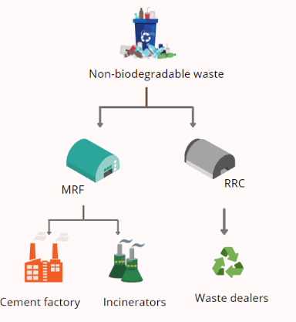

What happens to iron rods, thermocol, leather products, tyres, footwear, coconut shells, glasses and other low value items? Such waste is stored at Resource Recovery Centres (RRCs) from where the private waste management companies authorised by the civic body, take it for recycling/upcycling. For instance, Waste Winn Foundation collects thermocol and coconut shells.

“Thermocol is melted to make saree beads and buttons. Similarly, the coconut shells are used to produce alternative fuel

Solid-waste management, the collecting, treating, and disposing of solid material that is discarded because it has served its purpose or is no longer useful. Improper [*disposal of municipal solid waste*](https://www.conserve-energy-future.com/various-waste-disposal-problems-and-solutions.php) can create unsanitary conditions, and these conditions in turn can lead to pollution of the environment and to outbreaks of vector-borne disease—that is, diseases spread by rodents and insects.”

## Effects of Poor Solid Waste Management

### Litter Surroundings

Due to improper waste disposal systems, particularly by municipal waste management teams, wastes heap up and become a menace

### Impact on Human Health

Improper waste disposal can affect the health of the population living nearby the polluted area or landfills.

### Disease-causing Pests

This type of dumping of waste materials forces biodegradable materials to rot and decompose under improper, unhygienic and uncontrolled conditions.

After a few days of decomposition, a foul smell is produced, and it becomes a breeding ground for different types of disease-causing insects as well as infectious organisms

### Soil and Groundwater Pollution

[Toxic materials and chemicals](https://www.conserve-energy-future.com/top-10-worst-toxic-pollution-problems.php) may seep into the soil and pollute the groundwater. During the process of collecting solid waste, hazardous wastes usually mix with ordinary garbage and other flammable wastes making the disposal process even harder and risky.

### 6. Emission of Toxic Gases

When hazardous wastes like pesticides, batteries containing lead, mercury or zinc, cleaning solvents, radioactive materials, e-waste and plastics mixed up with paper and other non-toxic scraps are burned they produce dioxins, furans, polychlorinated biphenyls, and other gases. These toxic gases have the potential of causing various diseases, including cancer.

### Impact on Land and Aquatic Animals

Our carelessness with our waste and garbage also affects animals, and they suffer the effects of pollution caused by improperly disposed of wastes and rubbish.

Consuming styrofoam and cigarette butts have been known to cause deaths in marine animals. Animals are also at risk of poisoning while consuming grasses near contaminated areas or landfills as the toxins seep into the soil.

To address the issue of waste management and eliminate landfills and incinerators in the Virudhunagar district of Tamil Nadu, a group of local residents have been educating people about waste segregation, up-cycling, and recycling their garbage through a ‘Garbage Bank’.

The ‘Garbage Bank’, functioning since October 2, 2019, also segregates the waste from people’s houses so that it doesn’t end up in landfills and incinerators.

we receive their segregated garbage in four types; paper, plastic, metal, and e-waste items. Once this reaches the bank, we have employees who then re-segregate the garbage into 42 different items. we try to reuse most of the items given to us. We make cloth bags out of old cloth items